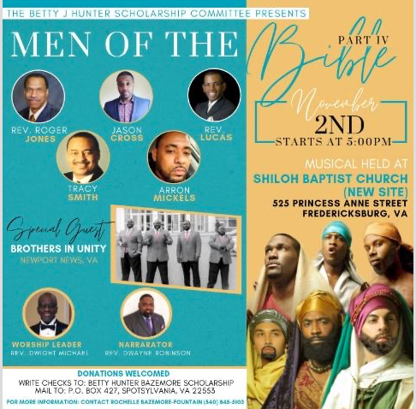

Saturday, November 2, 2019, at Shiloh Baptist Church, New Site, located at 525 Princess Anne Street, the Betty J. Hunter Bazemore Scholarship Fund Committee will present Part IV of the Men of the Bible. This wonderful event will take place at
5 pm and you don't want to miss it!

